Practical - 5
Practical Title: Registration Form with Frontend Validation and User-Friendly Error Handling

Create a student registration form with HTML5 input types and JavaScript

validation for name, email, mobile number, password, confirm password,

course, year, gender, and terms acceptance. Use Regular Expression for

validations.

Theory
1. Are correct input types and attributes used?
Yes, proper HTML5 types like type="text", type="email", type="tel", and type="password" are used, with matching id and for attributes on <label> elements.
2. Are validation errors displayed near the relevant fields?
No, validation errors are currently displayed using browser alert() pop-ups instead of inline error text near the fields.
3. Is password strength checked?
No, the validation only uses a basic alphanumeric regex (/^[a-zA-Z0-9]+$/) to check structure and matching passwords, but does not calculate or display a strength meter.
4. Is the form accessible using keyboard and screen-reader-friendly labels?
Yes, the form elements are fully tab-navigable via keyboard, and every input field is explicitly bound to a <label> using standard for attributes for screen readers.

Output
- Created an HTML registration form with input fields for personal details, credentials, course selection, and terms acceptance, using explicit labels for accessibility.
- Wrote JavaScript validation functions using Regular Expressions to verify field formats, match passwords, and confirm required selections.
- Prevented form submission when invalid input was detected and displayed alert boxes detailing the specific validation errors to the user.
To View Code: https://github.com/shreyajodhani/studenthub.git

Evidence of Work (Screenshots)
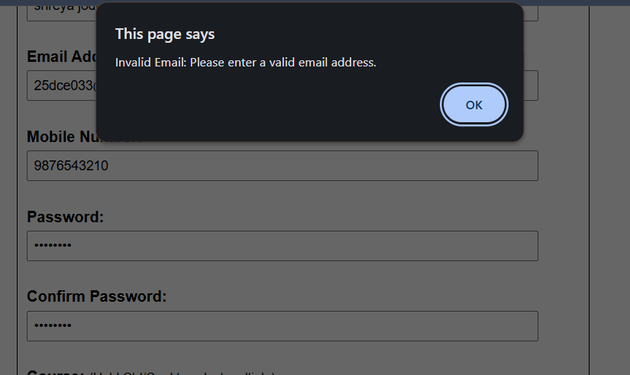
Description:
Login page of website, showing alert box when invalid email is entered.
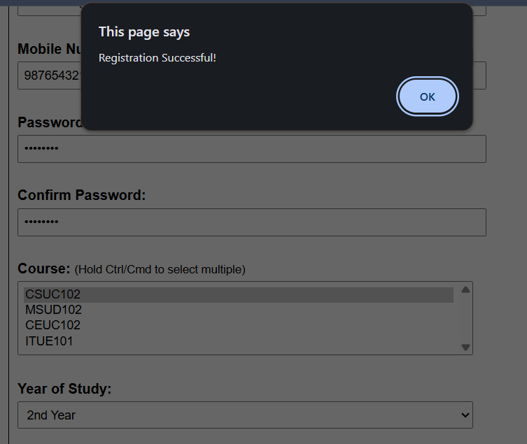

Description:
Login page of website showing successful login when all fields are entered correctly.

GitHub Repository Link: https://github.com/shreyajodhani/studenthub.git

Challenges Faced:

To not intermix all regex.

Learning Outcomes:
To check whether fields have valid input or not.
Faculty Remarks: (Keep this blank for faculty)

